ASDS-6306-CAPSTONE PROJECT REPORT

Title of the Project:
Sentimental Analysis of Social Media Tweets Using Machine Learning Techniques

Naga Venkata Koteswararao Padarthi
UTA ID: 1002200700

Name of the Proponents:
1. Dr. Afshan Boodhwani
2. Dr. Ce Brian Bian

TABLE OF CONTENTS
- Abstract
- Introduction
- Methodology
- Experiments
- Results
- Conclusion
- Future Work
- References

ABSTRACT
Predicting a user's personality from their digital footprints has become a computationally challenging problem due to the rapid increase in Internet users. The objective is to identify human personalities by gathering information from their tweets. I tried different machine learning algorithms and feature selection algorithms to find out the most suitable combinations of algorithms to predict personality.
In this work I used two datasets a test dataset with unprocessed textual statements and a training dataset with demographic information, Big Five scores, and personality labels. Tokenization, punctuation removal, stop word removal, and stemming were among the text preprocessing techniques used to transform unstructured text into useful features. The most informative characteristics were found using feature selection techniques such the Chi-Squared Test, Information Gain, and Pearson Correlation Coefficient. Support Vector Classifier (SVC) was trained to categorize personality labels after the OCEAN scores for the processed text were calculated.
From the experimental results, the model mapped language features psychological attributes and obtained promising accuracy on unseen data. The results show that machine learning can reliably extract significant personality insights from text. Applications including recommendation systems, targeted marketing, hiring screening, and mental health monitoring can all benefit from this strategy. Additionally, the work identifies areas that could be improved by utilizing deeper learning models and bigger datasets.

INTRODUCTION
Social media has become a crucial component of contemporary communication, allowing people to text their thoughts, emotions, and experiences. These virtual exchanges contain important psychological data that can be utilized to comprehend human nature. Predicting personality qualities from social mediadata has attracted a lot of attention lately since personality affects how people think, act, and react to various circumstances
One of the most popular frameworks for evaluating personality is the Big Five Personality Model, sometimes referred to as the OCEAN model. Openness, conscientiousness, extraversion, agreeableness, and neuroticism are its five main characteristics.
Every characteristic represents a distinct nature of human behavior and emotional processes. Personality assessment has historically involved psychological testing or questionnaires, which can be time-consuming and challenging to scale. Machine learning provides an automated substitute for personality prediction with the availability of textual data from social media platforms.
This project aims to develop a machine learning based model that predicts personality traits using linguistic cues derived from text data. The training dataset contains demographic information and Big Five scores, while the test dataset provides raw social media statements. The text data is preprocessed by removing special characters, tokenizing words, eliminating stop words, and applying stemming. Feature selection techniques including Pearson Correlation Coefficient, Information Gain, and Chi-Squared Test are used to extract relevant features. OCEAN scores are then computed for each user based on the selected features, and a Support Vector Classifier (SVC) is trained to classify the final personality label.

METHODOLOGY
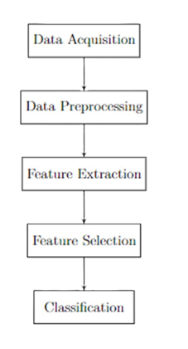
Data acquisition:
The dataset used in this project was obtained from social-media sentiment analysis datasets published on Kaggle. These datasets contain user-generated text tweets along with associated metadata. For personality prediction, these text samples were later enriched with OCEAN personality scores.
Link for the dataset: https://www.kaggle.com/datasets/abhi8923shriv/sentiment-analysis-dataset/data
Dataset Description:
Training Dataset
- Gender
- Age
- Openness
- Conscientiousness
- Extraversion
- Agreeableness
- Neuroticism
- Personality (Class Label)
This dataset contains numerical Big Five trait scores and the final personality. It was used to train the classification model.
Test Dataset
This dataset contains textual statements, user information, sentiment score, and other features. After preprocessing, only the following columns were retained:
- UserID
- Preprocessed Text
The purpose of this dataset is to evaluate the model on real world text and predict personality labels.
Data Preprocessing
Preprocessing was performed to clean the textual data and convert it into a suitable format for feature selection and modelling. The following steps were applied:
- Conversion to lowercase
- Removal of punctuation and special characters
- Stop word removal
- Stemming using Porter Stemmer
- Tokenization using NLTK
After preprocessing, each user had a combined text entry representing their social media activity. This text served as the input for feature selection.

Distribution plots for numerical variables
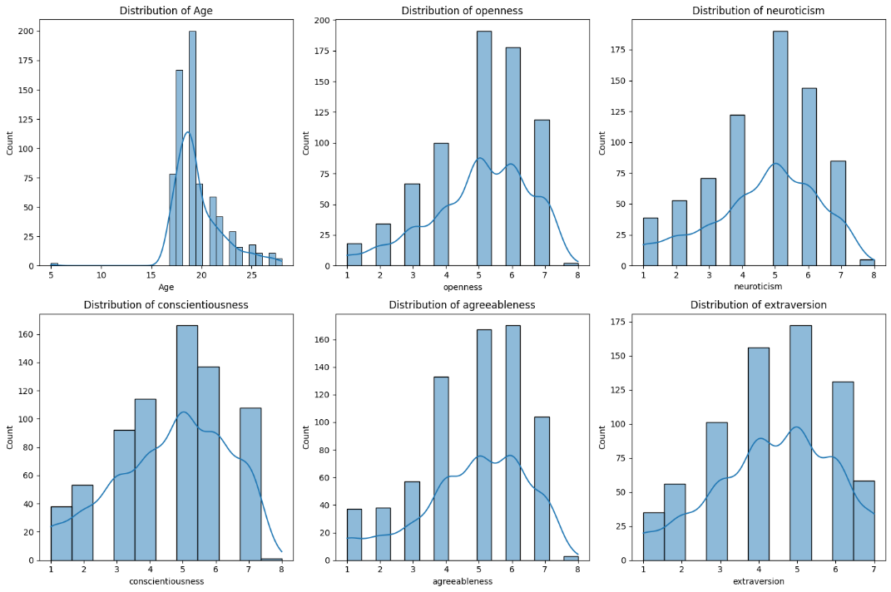
“Distribution plots of age and Big Five traits showed normal-like patterns"

Count of Personality by gender
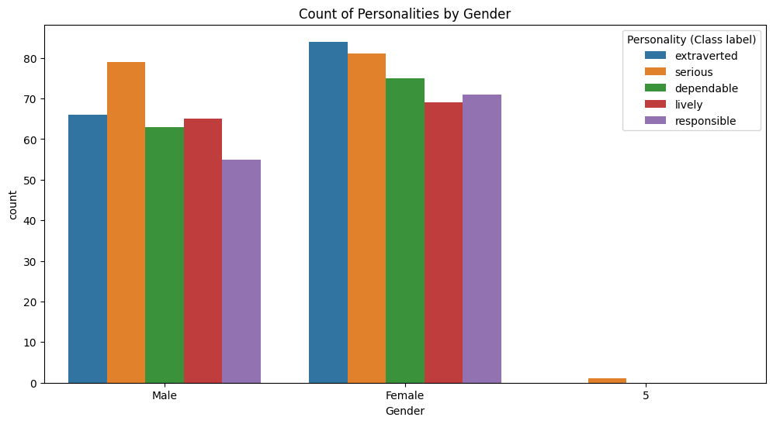
“Count plots showed balanced personality distribution across genders”

Feature Selection
Three feature selection methods were applied here
- Pearson Correlation Coefficient (PCC)
Measures linear correlation between features and personality scores.
- Information Gain (IG)
Computes how much a word contributes to reducing uncertainty in predicting personality.
- Chi-Squared Test
Evaluates dependence between words and class labels.
Each algorithm produced a different set of selected features. These features form the basis for generating OCEAN scores from text.

Machine Learning Model
The classification model was built using Support Vector Classifier (SVC). The model was trained using the training dataset, where:
- Input features: OCEAN trait scores and demographic information
- Output labels: Personality class (Extraverted, Serious, Dependable, Lively, Responsible.
The trained SVC model was then used to predict personality labels for users the test dataset. Machine learning algorithms such as Decision Trees, Random Forest, Logistic Regression, and Naïve Bayes.

EXPERIMENTS
Here we are evaluating the methodology. These experiments focused on preprocessing the textual data, extracting relevant features, generating OCEAN scores, and building machine learning models for personality classification.
Experimental Setup
All experiments were conducted using Python and Jupyter Notebook. The following libraries and tools were used:
- Pandas, NumPy – data handling and analysis
- tokenization, stopword removal, stemming
- Scikit-learn – feature selection and machine learning models
- Matplotlib, Seaborn – data visualization
The training dataset was used to train the machine learning models, and the pre-processed test dataset was used for personality prediction.

Text Preprocessing and Consolidation
Each user from the test dataset had multiple text entries. All entries belonging to the same user were combined into a single textual statement. Preprocessing steps included:
- Removal of punctuation and special characters
- Conversion to lowercase
- Tokenization
- Stop word removal
- Stemming using Porter Stemmer
This resulted in a cleaner and more standardized representation of the text for feature extraction.

Feature Selection Experiments
Three feature selection methods were applied individually to the pre-processed text:
- Pearson Correlation Coefficient (PCC)
- Information Gain (IG)
- Chi-Squared Test
Each algorithm produced a set of the most informative words. These words were used to compute OCEAN scores for each user. Multiple feature sets were evaluated to determine how feature selection impacts personality prediction performance.

OCEAN Score Calculation
For each user, OCEAN scores were calculated using sentiment polarity scores and linguistic patterns. The sentiment scores were derived using NLTK’s VADER model. The computed scores were mapped to the Big Five dimensions.
Model Training & Testing
The Support Vector Classifier (SVC) was trained using the training dataset containing:
- Big Five trait scores
- Demographic features
- Final personality labels
The computed OCEAN scores for the test dataset were fed into the trained SVC model to predict the personality labels. The predictions were compared to evaluate consistency and performance of the model.

RESULTS
This section presents the results of the experiments conducted on the personality prediction task. The objective of the evaluation was to measure the accuracy and effectiveness of different machine learning models trained using the Big Five trait scores
Features Selection | Decision Tree | Random Forest | Naive Bayes
PCC | 79.95% | 79.38% | 80.77%
Chi- Squared test | 89.96% | 89.87% | 73.15%
Information Gain | 78.97% | 79.40% | 82.53%

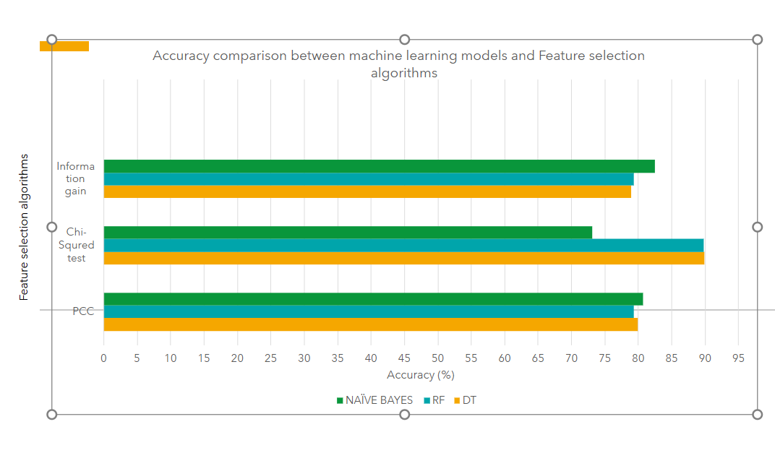

CONCLUSION
The Comparative analysis of Machine Learning algorithms for predicting personality traits using text data from people's tweets yielded promising results.​Among the three techniques tested, the Machine Learning Techniques Decision Tree, Random Forest with the combination of Chi-squared test demonstrated superior performance, achieving an accuracy of 89.96% & 89.87% for predicting the personality label.​
This project demonstrated that personality traits can be predicted from textual data using machine learning techniques. By combining text preprocessing, feature selection, and personality modelling, it is possible to infer meaningful psychological characteristics from social media content. The Big Five Personality Model served as a reliable foundation for representing personality through five measurable traits: Openness, Conscientiousness, Extraversion, Agreeableness, and Neuroticism.
Two datasets were used to implement this approach. The training dataset contained demographic information, Big Five scores, and personality labels, while the test dataset provided raw user-generated text. Preprocessing techniques such as tokenization, stop word removal, and stemming were applied to clean the text. Feature selection methods including Pearson Correlation Coefficient, Information Gain, and Chi-Squared Test helped identify the most informative features from the statements.
The OCEAN scores computed from linguistic patterns were used to build a Support Vector Classifier, which produced the most accurate personality predictions compared to other machine learning models. The results show that the model can successfully classify individuals into personality categories with satisfactory accuracy.
Overall, the findings confirm that personality prediction from text is feasible, scalable, and can be applied in real world scenarios such as recruitment, marketing, recommendation systems, and online behaviour analysis. The combination of natural language processing and machine learning provides a powerful framework for understanding human personality through digital interactions.
FUTURE WORK
The accuracy of personality prediction may increase by including larger datasets from multiple social media platforms. More text samples per user would create richer personality profiles. Techniques such as Recurrent Neural Networks (RNN), LSTM, or Transformer-based models like BERT could capture deeper language patterns and contextual meanings, leading to more accurate predictions.
Integrating emotional tone, sentiment polarity, and psychological lexicons may provide additional cues for personality classification. Techniques to explain feature contributions could make the model more transparent and interpretable for psychological research. Future studies should address privacy concerns and ensure that personality prediction models are used ethically and responsibly.

REFERENCE
- Ergu, ˙Izel and Is¸ık, Zerrin and Yankayıs¸, ˙Ismail. Predicting personality with Twitter data and machine learning models.
- V. S. K. C. Konakalla, C. N. S. M. Kona, T. H. P. Chintamaneni, V. Boddu and V. S. Dhuli, "Personality Prediction Based on Tweets of Russo-Ukrainian Conflict in Social Networks," 2023 IEEE 20th India Council International Conference (INDICON), Hyderabad, India, 2023, pp. 1143-1148, doi: 10.1109/INDICON59947.2023.10440884.
- X. Sun, B. Liu, J. Cao, J. Luo and X. Shen, ”Who Am I? Personality Detection Based on Deep Learning for Texts,” 2018 IEEE International Conference on Communications (ICC), Kansas City, MO, USA, 2018
- Gita Safitri, Erwin Budi Setiawan Optimization Prediction of Big Five Personality in Twitter Users, Vol 6 No 1 (2022): February 2022 Section Information Systems Engineering Articles
- P. D. J. Tejas Bakade, Siddhant Deshpande, Omkar Pethe, Shreyas Kale, Yashwant Madane, ”Big Five Personality Prediction Using Machine Learning Algorithms,” MSEA, vol. 71, no. 3, pp. 1128 -, Aug. 2022.
- Jiawei Yao. (2019). Automated Sentiment Analysis of Text Data with NLTK. Journal of Physics: Conference Series, 1187(5), 052020. doi: 10.1088/1742-6596/1187/5/052020
- N. Alsadhan and D. Skillicorn, "Estimating Personality from Social Media Posts", 2017 IEEE International Conference on Data Mining Workshops (ICDMW), 2017. Available: 10.1109/icdmw.2017.51 [Accessed 1 March 2022].
- Alessandri, G., & Vecchione, M. (2012). The higher-order factors of the Big Five as predictors of job performance. Personality and Individual Differences, 53, 779–784. http://dx.doi.org/10.1016/j.paid.2012.05.03
- A. Naz, H. U. Khan, A. Bukhari, B. Alshemaimri, A. Daud and M. Ramzan, “Machine and Deep Learning for Personality Traits Detection: A Comprehensive Survey and Open Research Challenges,” Artificial Intelligence Review, 2025.
- M. D. Kamalesh et al., “Personality prediction model for social media using Binary-Partitioning Transformer with TF-IGM,” Computers in Human Behavior Reports, 2022.
- J. Serrano-Guerrero, “Combining machine learning algorithms for personality trait recognition using lexical and semantic features,” [Journal/Conference], 2024.
- F. M. Deilami, “Deep learning based method for personality recognition from text using CNN + AdaBoost,” arXiv preprint, 2022.
- K. Yang et al., “DeepPerson: A Deep Learning Artifact for Text-Based Personality Detection,” INFORMS Journal, 2023
- V. Hemanth, “Personality Detection through Text Using Deep Learning,” Journal of Nonlinear Analysis and Optimization, vol. 15, no. 1, 2024.

COURSERA CERTIFICATION
As part of my continuous learning effort during this capstone project, I completed the IBM Data Engineering Professional Certificate through Coursera. The program consisted of sixteen individual courses, covering topics such as SQL, relational and NoSQL databases, data warehousing, scripting in Linux, Python programming, Apache Spark, ETL pipelines, and dashboarding. Each module included hands-on exercises and practical assignments, which allowed me to actively apply the material rather than simply learn it in theory.

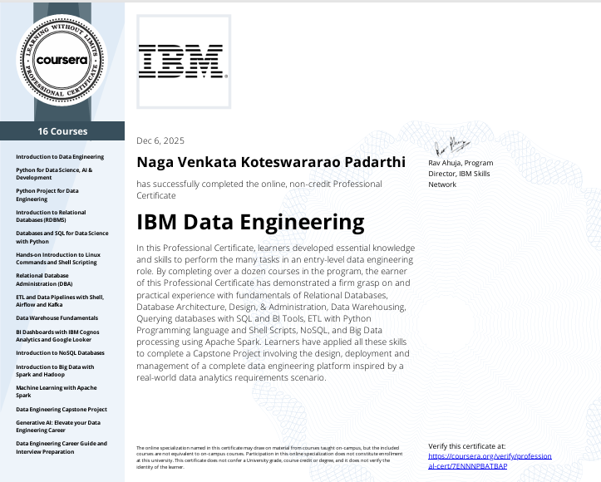
Completing this certification gave me a strong foundation in data engineering, and I genuinely appreciate the opportunity to gain practical knowledge from industry-aligned content. The skills, exercises, and exposure I received from the program were valuable and contributed to my personal growth and the successful completion of this project.

